فهـرسـت نشـریـات و مجـلات
-------------------------------------------------------------------------------
Health Education and Behavior
Health Education Research
Journal of Education and Health Promotion
Health Education Journal

Health Education
Education for Health
International Journal of Health Promotion
Interface: Communication, Health, Education
American Journal of Health Education

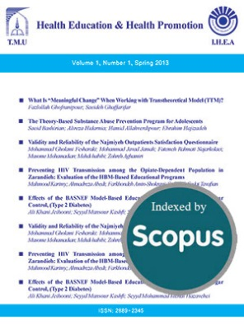  Health Education and Health Promotion  -------------------------------------------------- |   International Journal of Health Promotion and Education  --------------------------------------------------
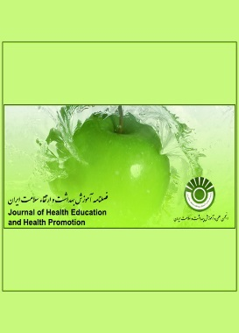  Iranian Journal of Health Education  and Health Promotion  -------------------------------------------------- | 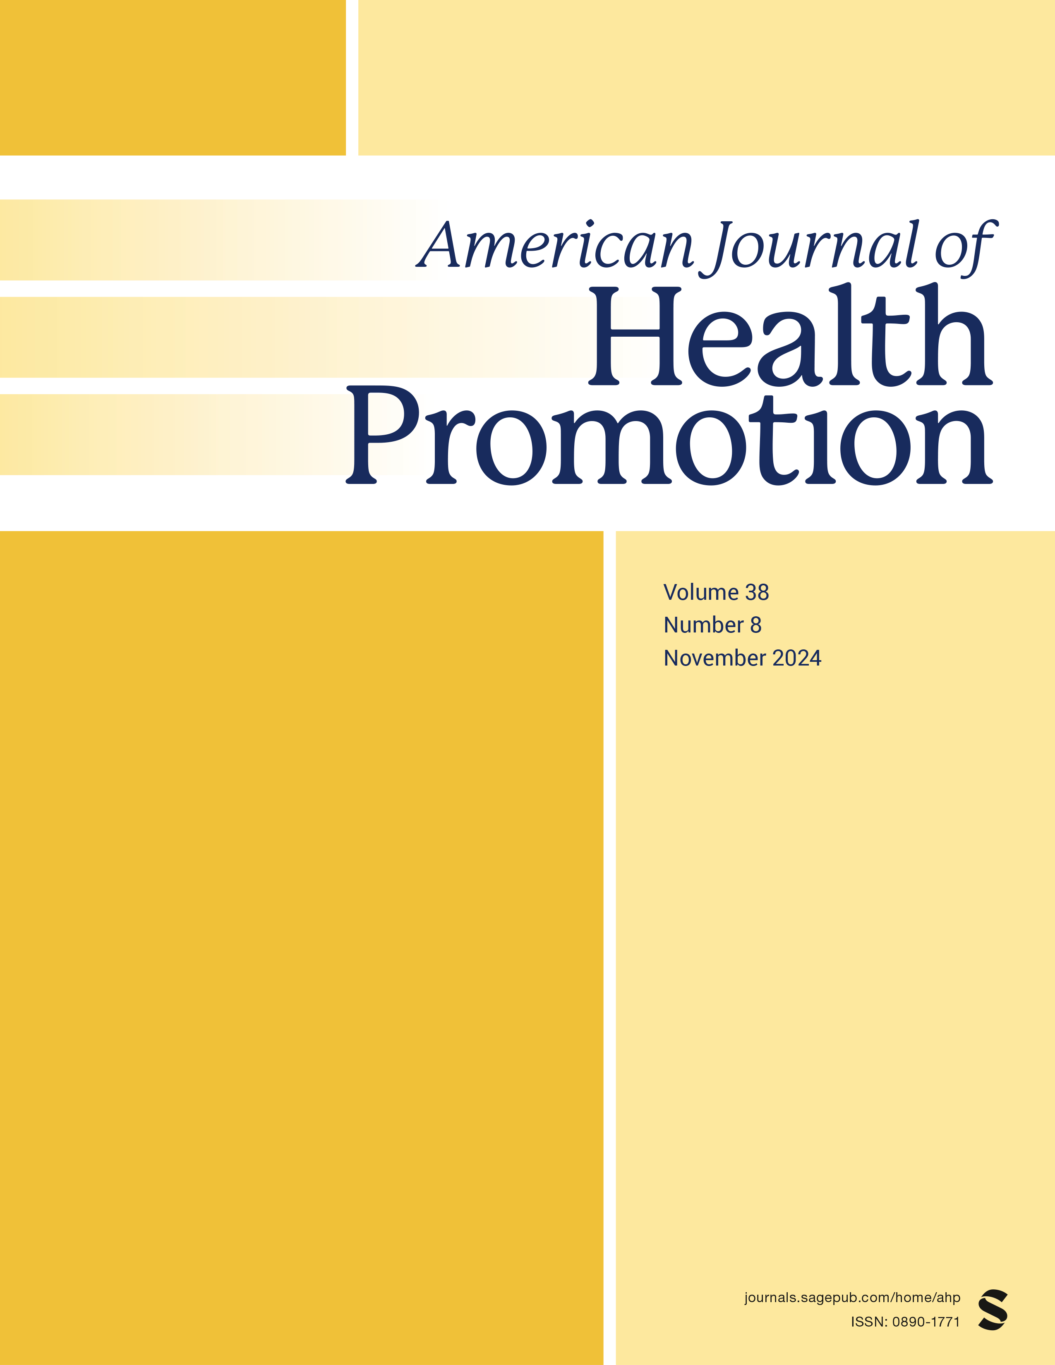  American Journal of Health Promotion (AJHP)  --------------------------------------------------
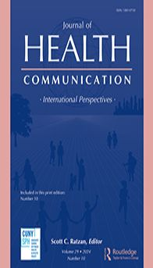  Journal of Health Communication  -------------------------------------------------- | 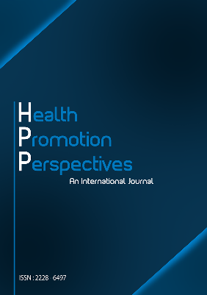  Health Promotion Perspectives (HPP)  --------------------------------------------------
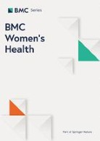  BMC Women's Health  -------------------------------------------------- |   BMC Public Health  --------------------------------------------------
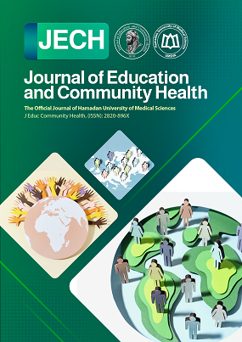  Journal of Education and Community Health  -------------------------------------------------- | 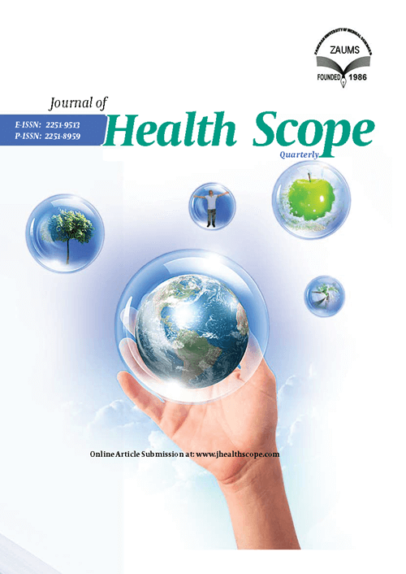  Health Scope  --------------------------------------------------
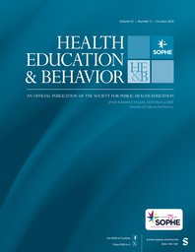  Health Education & Behavior (HE&B)  -------------------------------------------------- | 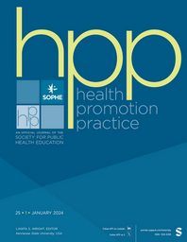  Health Promotion Practice (HPP)  --------------------------------------------------
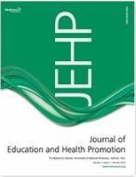  Journal of Education and Health Promotion  -------------------------------------------------- |   Health Education Journal (HEJ)  --------------------------------------------------
  Health Education  -------------------------------------------------- | 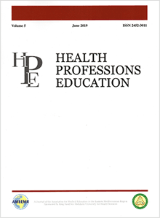  Health Professions Education  --------------------------------------------------
https://www.jehp.net/aboutus.asp

